CSS - Properties

Position

Position method for the element, the default position is static and any other means the element is classed as positioned:

* static - Element in order of document flow
* absolute - Positioned relative to its first positioned ancestor element
* fixed - positioned relative to browser window
* relative - positioned relative to its normal position in document flow
* sticky - positioned based on user scroll (positioned as relative until a given office position is met in the viewport, then it converts to fixed)

Float

Float defines how the element is positioned in its container, the default is left:

* left - element is positioned to the left
* right - element is positioned to the right

Padding and Margin

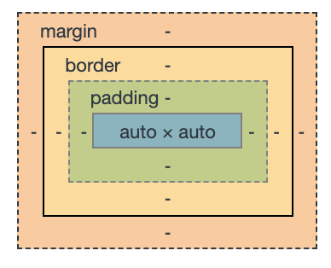

Margin is offset from container element

Padding is offset of child elements inside element